HAMEG LISN Rohde Schwarz (Seller: Scientific India)

## Link: http://www.scientificindia.com/products/line-impedance-stabilization-network.aspx

* The Line Impedance Stabilization Network HM6050-2 is designed compliance level measurements conducted EMC emissions.
* The unit complies with VDE0876 and CISPR Pu41.16 (band A and B) regulations. And can be operated manually or PC controlled via the built in RS232 interface.
* It is designed and built using air core inductors to avoid saturation at peak current loads.
* The unit comprises an artificial hand simulation per ANSIC6.3.4, as well as a PE simulation network (50mH II 50W) which can be bypassed for the protection of sensitive inputs the output signal can be for limited by a switchable transient limiter.
* The HM6050-2 LISN is used with a spectrum analyzer or measurement receiver.
* The continuous ratings of 16A makes the unit suitable for many types of single phase equipment.
* The maximum frequency is 63Hz.
* The HM6050-2 can be supplied range of power outlets such as IEC16A, UKl3A, and European EMC test bench standard sockets.

The LISN is, in principle, a high pass filter when viewed from EUT (equipment under test) to the measurement terminal. The high pass filter output signal is switched from either conductor to the measurement terminal. Viewed from the power line side the LISN is a low pass filter that isolates disturbance from the power line by up to 40dB.  
Compact size and light weight make the HM6050-2 an easy to use tool for commercial, CISPR based conducted emission testing on your EMC test bench. It can be used for in house compliance level measurements, reducing the need for test house time.

# Schwarzbeck NSLK 8127

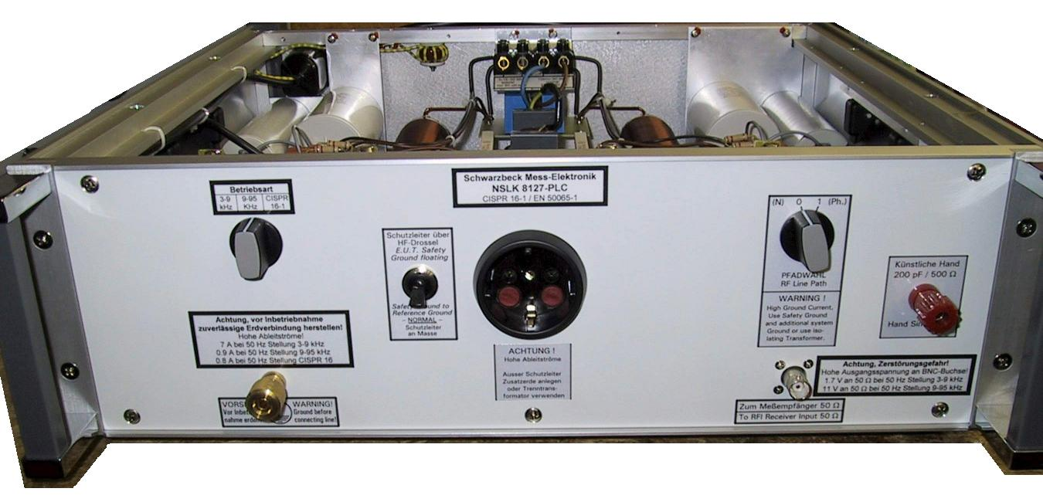



# Spice Model of LISN (Designed in LTSpice)

